**Module-3**

Python Programming

|  |  |
| --- | --- |
| Assignment Date | 19 September 2022 |
| Student Name | Varsha.R |
| Student Roll Number | 311019104097 |
| Maximum Marks | 2 Marks |

**Question 1:**

Consider a list (list=[]).you can perform the following commands:

Insert I e: Insert integer at position

Print: print the list

Remove e: Delete the first occurrence of integer

Append e: Insert integer at the end of the list.

Sort: Sort the list.

Pop: pop the last element from the list.

Reverse: Reverse the list.

Initialize your list and read in the value of followed by lines of commands where each command will be of the types listed above. Iterate through each command in order and perform the corresponding operation on your list.

list = [1, 2, 4] #Creation of list

print(list) #prints the list

list.insert(2,3) #Inserting interger(3) at position index(2)

print(list)

list.remove(1) #Deleting the first element

print(list)

list.append(5) #Inserting integer at the end of the list

print(list)

list.sort() #Sorting the list

print(list)

list.pop(3) #Pop the last element of the list

print(list)

list.reverse() #Reversing the list

print(list)

**Output:**

[1, 2, 4]

[1, 2, 3, 4]

[2, 3, 4]

[2, 3, 4, 5]

[2, 3, 4, 5]

[2, 3, 4]

[4, 3, 2]

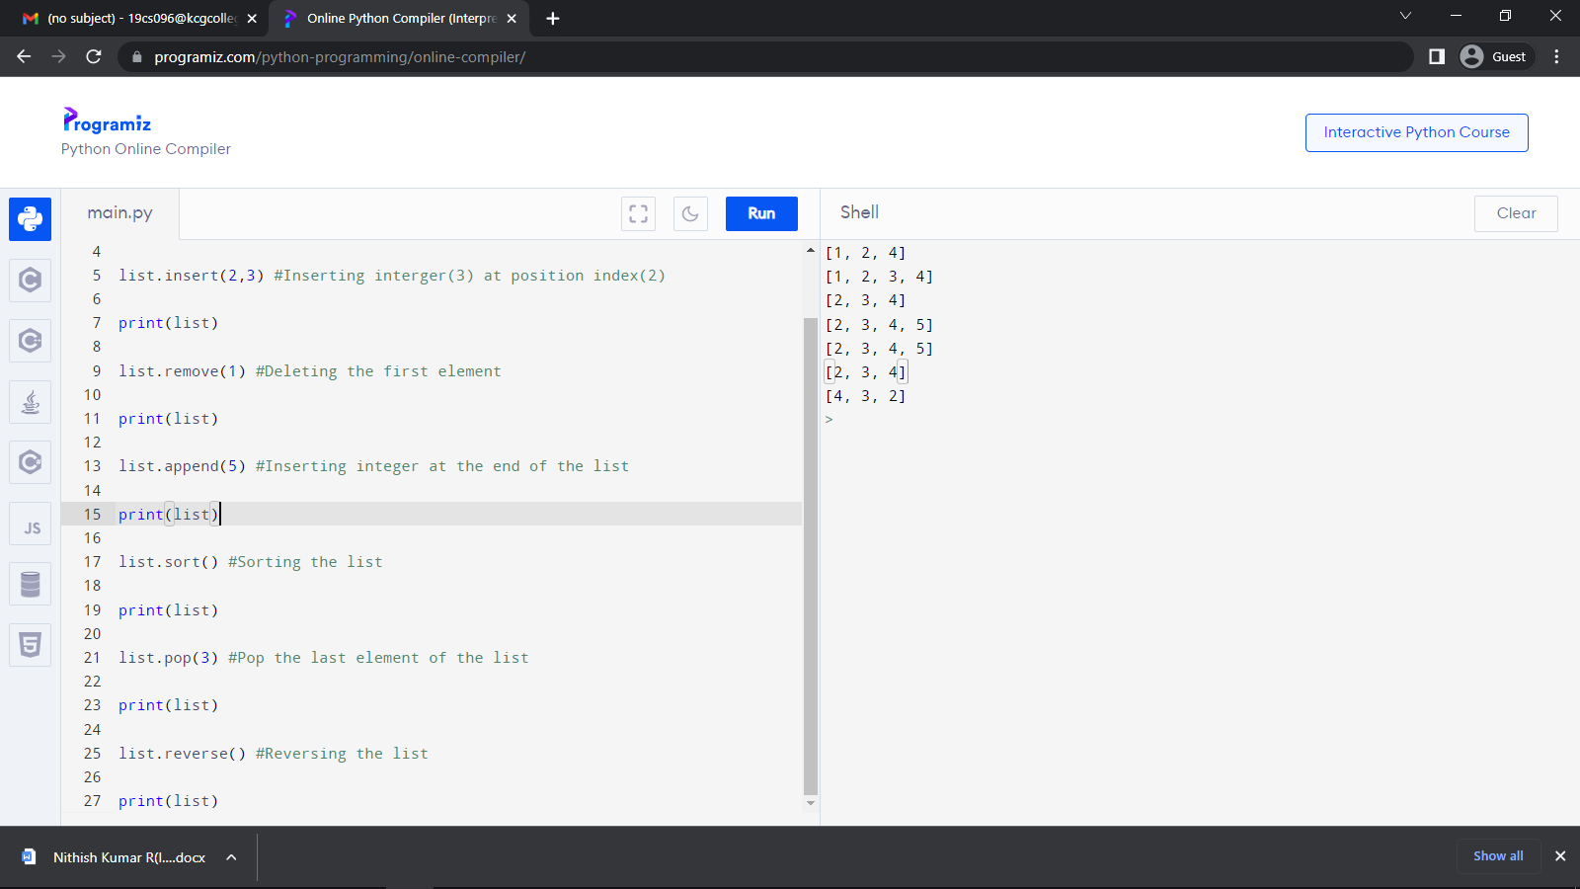

**Question 2:**

Write a calculator program in python?

def add(P, Q):

return P + Q

def subtract(P, Q):

return P - Q

def multiply(P, Q):

return P * Q

def divide(P, Q):

return P / Q

print ("Please select the operation.")

print ("a. Add")

print ("b. Subtract")

print ("c. Multiply")

print ("d. Divide")

Answer = input("Please enter choice (a/ b/ c/ d): ")

num_1 = int (input ("Please enter the first number: "))

num_2 = int (input ("Please enter the second number: "))

if Answer == 'a':

print (num_1, " + ", num_2, " = ", add(num_1, num_2))

elif Answer == 'b':

print (num_1, " - ", num_2, " = ", subtract(num_1, num_2))

elif Answer == 'c':

print (num1, " * ", num2, " = ", multiply(num1, num2))

elif Answer == 'd':

print (num_1, " / ", num_2, " = ", divide(num_1, num_2))

else:

print ("This is an invalid input")

**Output:**

Please select the operation.

a. Add

b. Subtract

c. Multiply

d. Divide

Please enter choice (a/ b/ c/ d): a

Please enter the first number: 7

Please enter the second number: 5

7 + 5 = 12

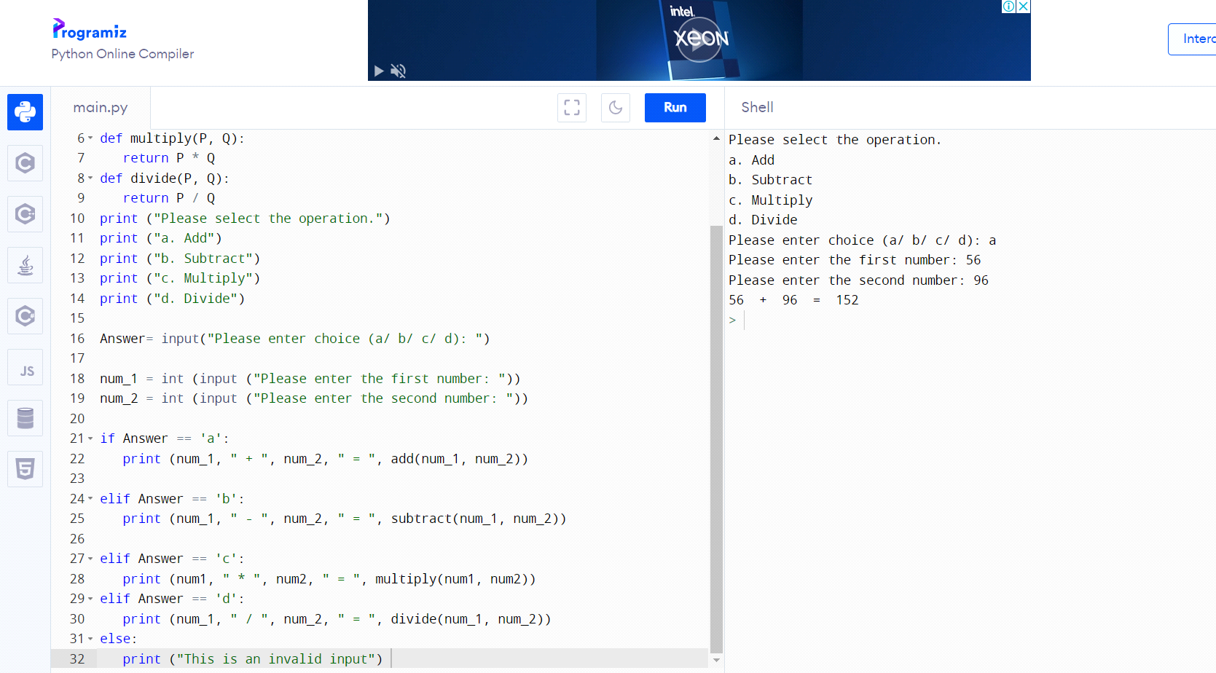

**Question 3:**

Write a program to concatenate ,reverse and slice a string?

#concatenate of two string:

s1="Hello"

s2="World!"

s3=s1+""+s2

print (s3)

print("****")

#Slice the string

print(s3[2:5])

print("****")

#Reverse the two string

def my_function(a):

return a[::-1]

x = my_function("hello my world")

print(x)

**Output:**

HelloWorld!

****

llo

****

dlrow ym olleh

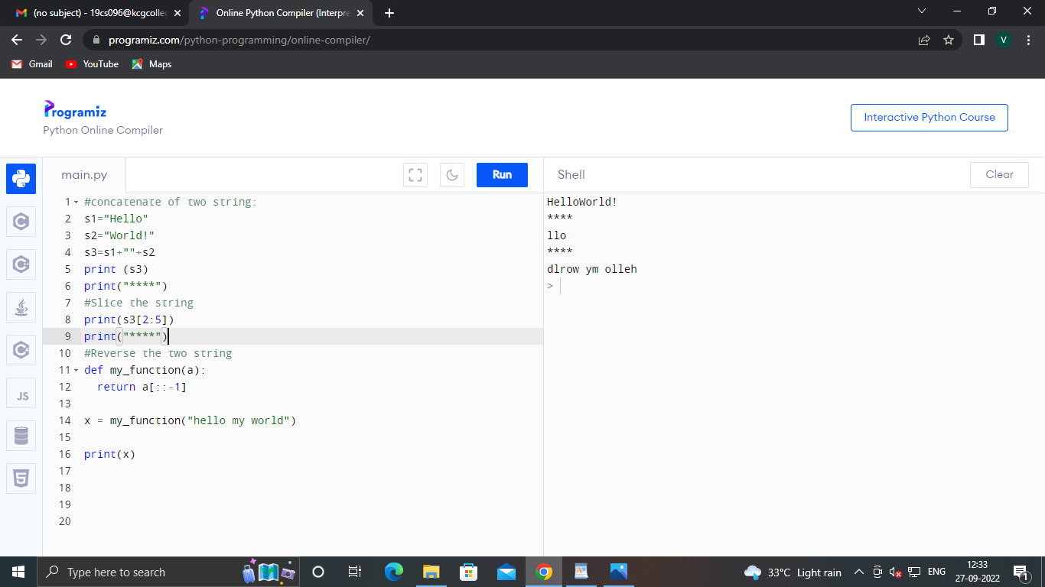

**Question 4:**

Why is python a popular programming language?

### **Easy to Learn and Use**

### **Mature and Supportive Python Community**

### **Support from Renowned Corporate Sponsors**

### **Hundreds of Python Libraries and Frameworks**

**Question 5:**

What are the other frameworks that can be used with python?

1. Bottle
2. Flask
3. Django
4. Web2py
5. CherryPy
6. AIOHTTP

Etc.

**Question 6**:

Full form of WSGI?

* WSGI stands for Web Server Gateway Interface